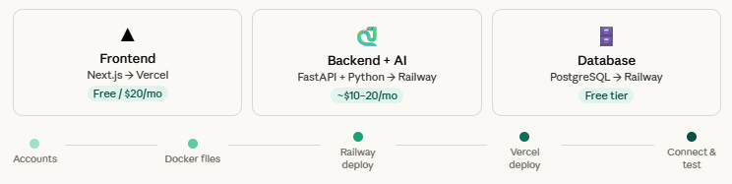
Sign up for Railway
Railway hosts your FastAPI backend, AI services, and PostgreSQL database.
Go to railway.app and sign up with your GitHub account — this links directly to your WeightLoss repo.
Sign up for Vercel
Vercel hosts your Next.js frontend.
Go to vercel.com and sign up with GitHub. It will detect Next.js automatically — zero configuration needed.
Create a Dockerfile in backend/
This tells Railway (and later AWS) how to package your FastAPI app. Create a file called Dockerfile inside your backend/ folder with this content:
FROM python:3.12-slim
WORKDIR /app
COPY requirements.txt .
RUN pip install -r requirements.txt
COPY . .
EXPOSE 8000
CMD ["uvicorn", "app.main:app", "--host", "0.0.0.0", "--port", "8000"]

Create a Dockerfile in ai-services/
Same pattern for your AI gateway service. Create a Dockerfile inside ai-services/:
FROM python:3.12-slim
WORKDIR /app
COPY requirements.txt .
RUN pip install -r requirements.txt
COPY . .
EXPOSE 8001
CMD ["uvicorn", "app.main:app", "--host", "0.0.0.0", "--port", "8001"]

Commit and push both files
In your terminal, from the root of the repo:
git add .
git commit -m "add dockerfiles for backend and ai-services"
git push

Create a new Railway project
In Railway, click "New Project" → "Deploy from GitHub repo" → select your WeightLoss repo. Railway will ask which folder — select backend/.
Add a PostgreSQL database
In your Railway project, click "+ New" → "Database" → "PostgreSQL". Railway creates the database and automatically gives you a DATABASE_URL environment variable.
Set environment variables
In your backend service on Railway, go to Variables tab and add:
POSTGRES_URL → (copy from your Railway PostgreSQL service)
BACKEND_JWT_SECRET → (make up a long random string, 32+ chars)
BACKEND_JWT_ALGORITHM → HS256
BACKEND_ACCESS_TOKEN_EXPIRE_MINUTES → 60

Deploy AI services as a second service
Click "+ New" → "GitHub Repo" again in the same project, select ai-services/ folder. Add your AI provider API keys (e.g. OPENAI_API_KEY) as variables here.
Run database migrations
In Railway, go to your backend service → Settings → add a deploy command. This runs Alembic migrations every deploy:
alembic upgrade head && uvicorn app.main:app --host 0.0.0.0 --port 8000

Once deployed, Railway gives you a public URL like backend-production-xxxx.up.railway.app — copy this, you need it for Vercel.
Import your repo in Vercel
In Vercel, click "Add New Project" → select your WeightLoss GitHub repo. Vercel detects Next.js automatically. Under "Root Directory", set it to frontend
Add environment variables
Before clicking deploy, add these environment variables in Vercel:
NEXT_PUBLIC_API_URL → https://your-backend.up.railway.app
NEXT_PUBLIC_AI_URL → https://your-ai-service.up.railway.app

Click Deploy
Hit Deploy. Vercel builds your Next.js app and gives you a live URL like weightloss.vercel.app. You can also connect a custom domain (e.g. myweightlossapp.com) in Vercel's domain settings for free.
Test the backend health check
Visit your Railway backend URL in your browser with /docs appended — FastAPI auto-generates an interactive API explorer. If you see it, your backend is live.
https://your-backend.up.railway.app/docs

Test the frontend
Visit your Vercel URL, try to register a new account, and log in. If auth works, your frontend → backend connection is good.
Check Railway logs if anything breaks
In Railway, click your service → Deployments → click the latest deployment → View Logs. Error messages appear here in plain text.
🔒 Security reminder: before launch, switch JWT tokens from localStorage to httpOnly cookies in your frontend. This protects your users' health data from common browser attacks.
Your Dockerfiles are already ready
The Dockerfiles you created in Phase 2 are exactly what AWS ECS (Elastic Container Service) uses. No rewriting — just push your Docker images to AWS ECR (a container registry) and point ECS at them.
Database migrates to AWS RDS
Railway PostgreSQL → AWS RDS PostgreSQL is a straightforward export/import. Since you're using Alembic migrations, the schema is fully reproducible — just run alembic upgrade head on the new database.
Trigger: when to migrate
Consider migrating when your Railway bill exceeds ~$50/month, you need auto-scaling, or you need SOC2/HIPAA compliance for health data. Until then, Railway is more than enough.

AI API KEY STRATEGY

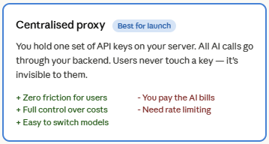 | 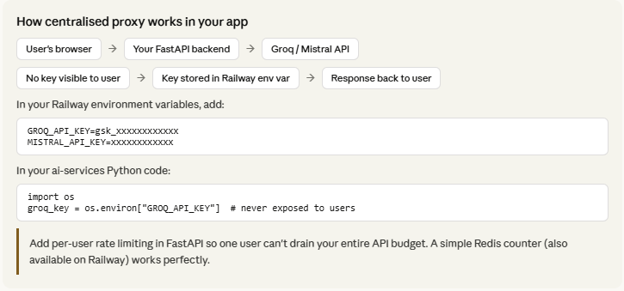
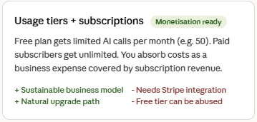 | 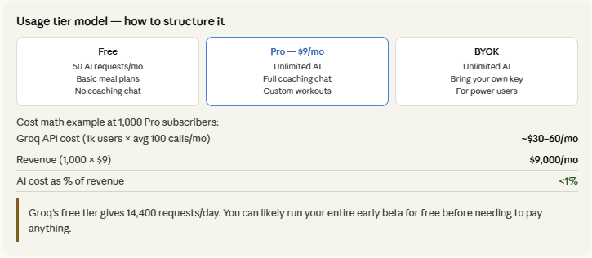
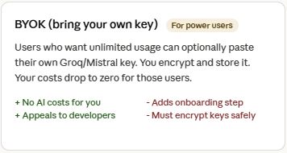 | 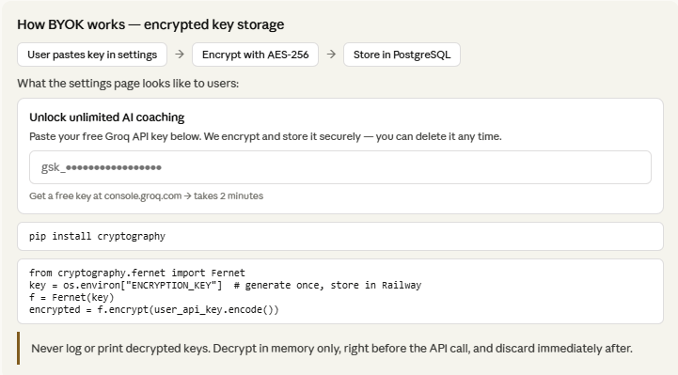
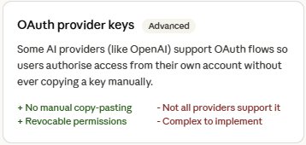 | 